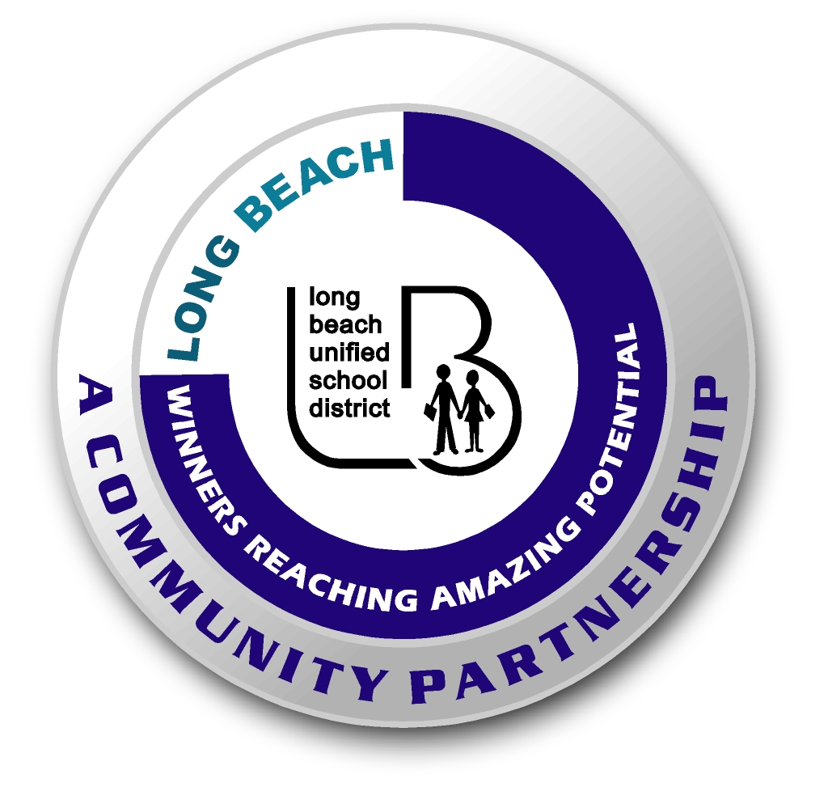
Long Beach WRAP

Lesson Title or Topic: Ecosystems in a Box

Program Leader: _____________________________ Date: __________

Grade Level: 6-8th School Site: __________________________

Materials Needed: (List)
- Any materials they can collect from the surrounding area that represents living and nonliving (biotic/abiotic) things in their ecosystem. (Use magazines for pictures if needed)
- Internet to research different types of ecosystems
- Shoebox or larger
- Art supplies, paint, glue colored pencils, crayons, etc

Preparation Time: 15 min Lesson time: Group project 2-3days

Content Standard(s) Ecology 5a-e

What will be learned from this activity? (Objective)
- Students will build an ecosystem which will illustrate the different living and non-living factors unique to that ecosystem.

Steps of the lesson: (Scientific Method of Investigation)

Introduction: (Questions/Hypothesis):
- Research different types of ecosystems on the internet or in your science text.
- Choose one and collect pictures of living samples to place in you exhibit.

Instruction:
- Assist students with the research

Activity: (Procedure)
- Students are going to build a three dimensional model of their chosen ecosystem.
- Their model should include the living and non-living aspects of the ecosystem they have chosen. For example: animal and plant life, location (mountains, shoreline, desert etc.).
- A written description of all the characteristics (climate, elevation, precipitation, etc.) of the ecosystem along with a world map of its locations.

Closure: (Conclusions/Results)

- Written assignment or oral presentation. Explain why you chose this ecosystem and one animal or plant you found interesting.

